JDE World Program Documentation
There are six options available from the opening JDE Edwards menu of the program. This screen appears below:
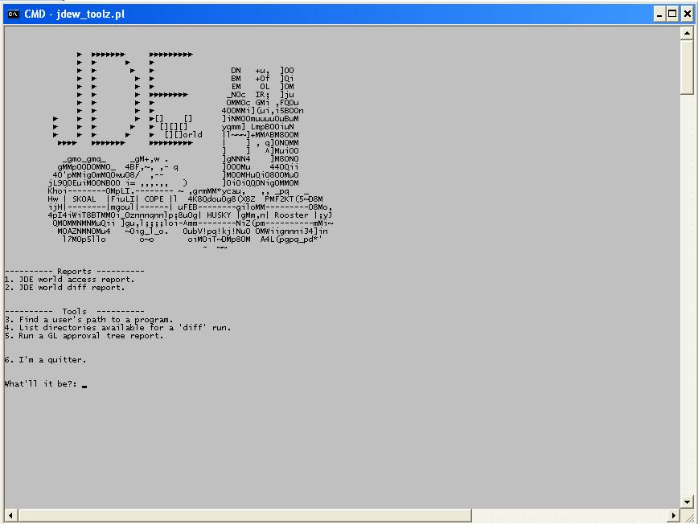
This document will detail the purpose and use of each of these six options. Each of them is very easy to use and only require a couple of pieces of information from the user to execute.

Option 1. (“JDE world access report.”)
This is the main option that will run an access report. Upon entering a 1 at the prompt, the user is taken to the screen below and asked to pick the system they want to run an access report for…in this case we can choose from the HQ corporate system or the Winery system:

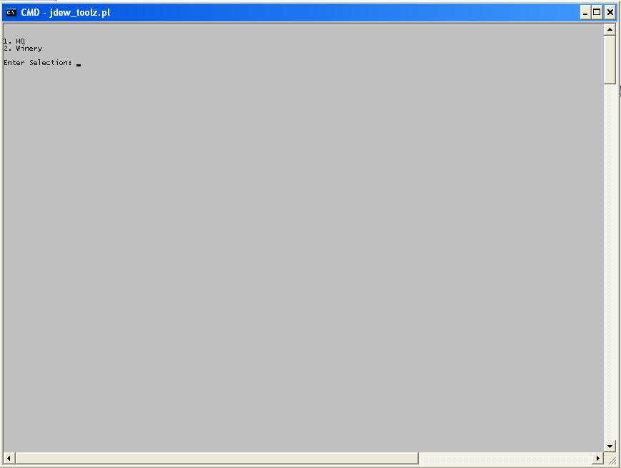
All you have to do is enter a 1 to run a report for the corporate system or a 2 to run a report for the winery system. When you enter a “1” or “2” you are then taken to the next screen which will prompt you for your username and password:

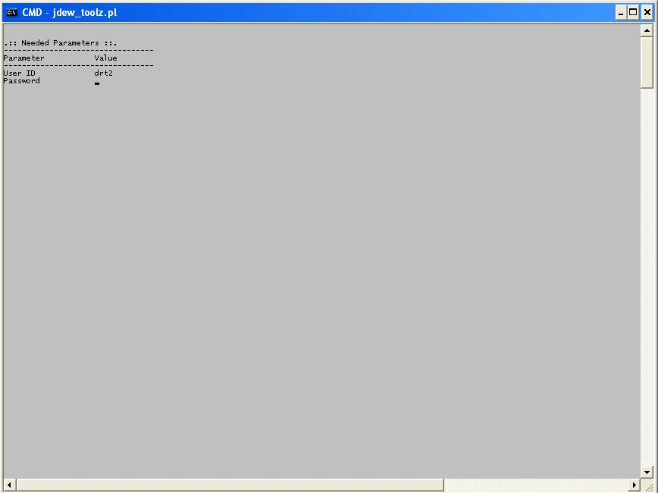
Here you would simply enter your user ID, which is most likely your 2 ID. You have to use the ID which has ODBC and query access to the AS400. At the winery it’s most likely a USTIAD type of ID. When you hit return you will be prompted for your password. Note that when you enter your password it does NOT echo to the screen. This is normal, it’s just a security measure so that someone looking over your shoulder won’t see your password. When you hit return the script will kick off and run. The script will provide some feedback on its progress and tell you when it’s completed the run:

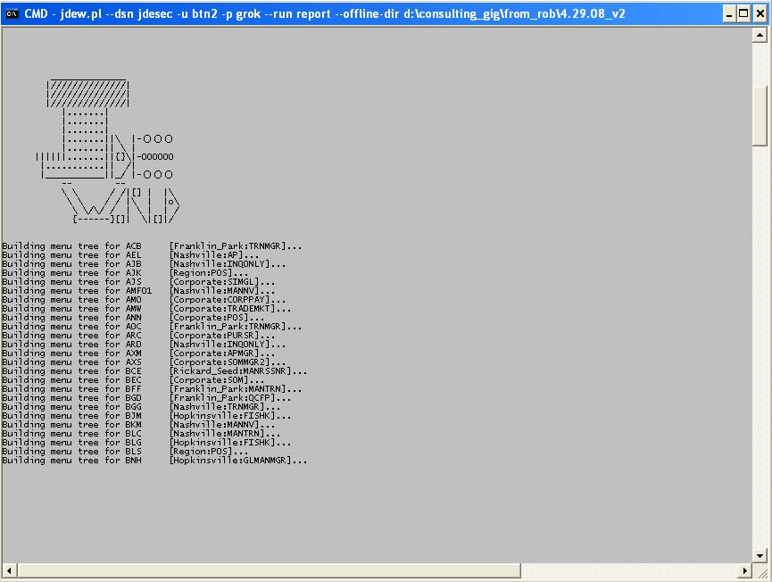
That’s all you need to do to run an access report for the HQ or Winery. This script will take care of everything and will create a directory for you in the top level directory that contains the files…like this:
